**Day 2 Summary of Key Concepts**

**Lecture: Qubits, Gates, & Circuits**

**Summary:** In lecture today, we explored the first three layers of the quantum stack: qubits, gates, and circuits. We learned a new method of representing qubits - the **Bloch sphere**. We also used this notation to learn how two fundamental gates in quantum computing, the **X and Hadamard gates**, apply to qubits. Finally, we strengthened our understanding of **quantum measurement.** Here are the key concepts we discussed:

1. **Review- Ket notation:** The ket notation is used to represent the state of qubits. Putting a “0” or a “1” inside a ket shows that it represents a quantum state

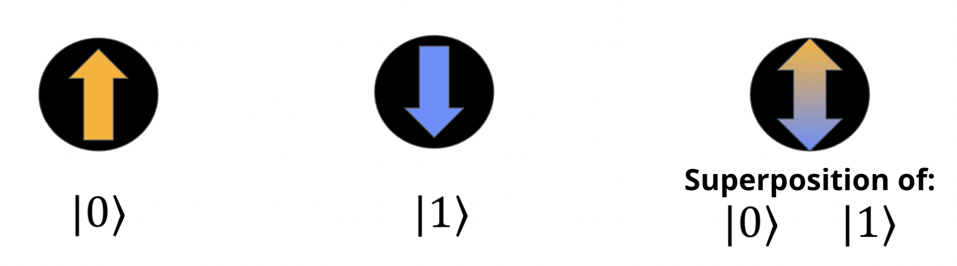

1. **New notation- The Bloch sphere:** The Bloch sphere is a way to visually represent qubit states. It overcomes the limitations of the arrow notation that we’ve used so far to visualize qubit states, which is not very good for representing superposition states. **Any qubit state can be represented on the Bloch sphere.**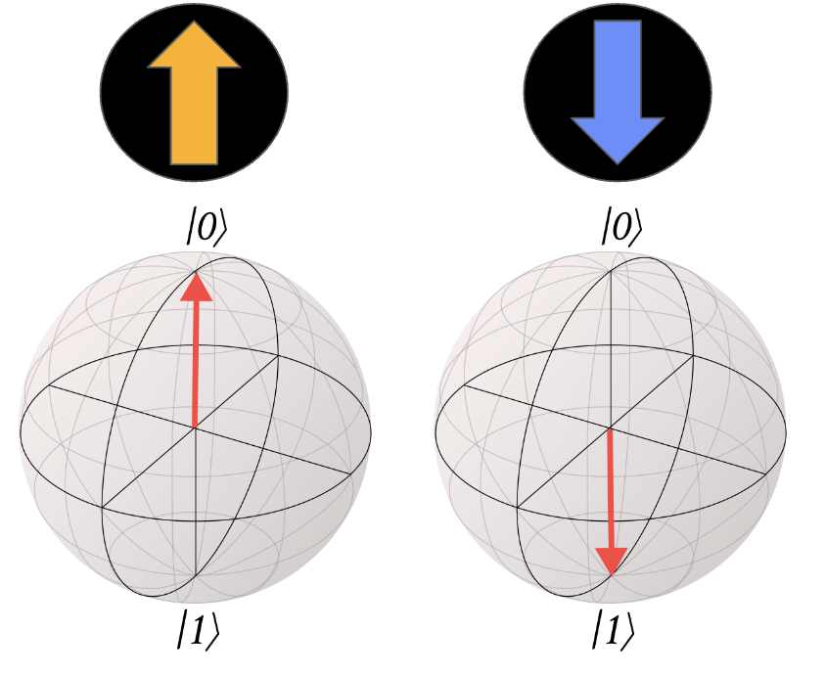
   1. The [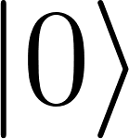](https://www.codecogs.com/eqnedit.php?latex=%7C%200%20%5Crangle%20#0) state is located at the top of the Bloch sphere, and the [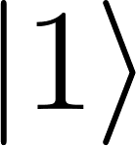](https://www.codecogs.com/eqnedit.php?latex=%7C%201%20%5Crangle%20#0) state at the bottom.
   2. **Any other state on the Bloch sphere represents a superposition of** [****](https://www.codecogs.com/eqnedit.php?latex=%7C%200%20%5Crangle%20#0) **and** [****](https://www.codecogs.com/eqnedit.php?latex=%7C%201%20%5Crangle%20#0). A superposition can be **equal**, meaning that [](https://www.codecogs.com/eqnedit.php?latex=%7C%200%20%5Crangle%20#0) and [](https://www.codecogs.com/eqnedit.php?latex=%7C%201%20%5Crangle%20#0) contribute equally to the state, or **unequal**, meaning that either [](https://www.codecogs.com/eqnedit.php?latex=%7C%200%20%5Crangle%20#0) contributes more or [](https://www.codecogs.com/eqnedit.php?latex=%7C%201%20%5Crangle%20#0) does. If the state is closer to [](https://www.codecogs.com/eqnedit.php?latex=%7C%200%20%5Crangle%20#0), it has a greater contribution from [](https://www.codecogs.com/eqnedit.php?latex=%7C%200%20%5Crangle%20#0). If it is closer to [](https://www.codecogs.com/eqnedit.php?latex=%7C%201%20%5Crangle%20#0), it has a greater contribution from [](https://www.codecogs.com/eqnedit.php?latex=%7C%201%20%5Crangle%20#0).

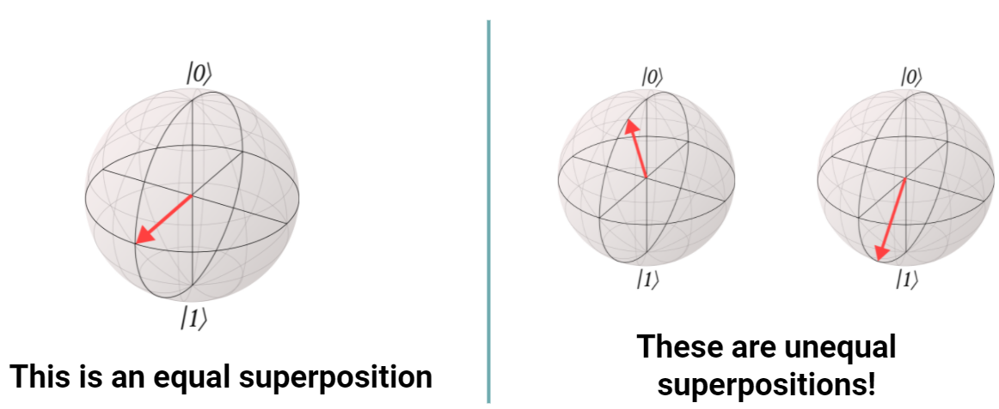

**Key Concept:** Two key superposition states to know are the |+> and |-> state:

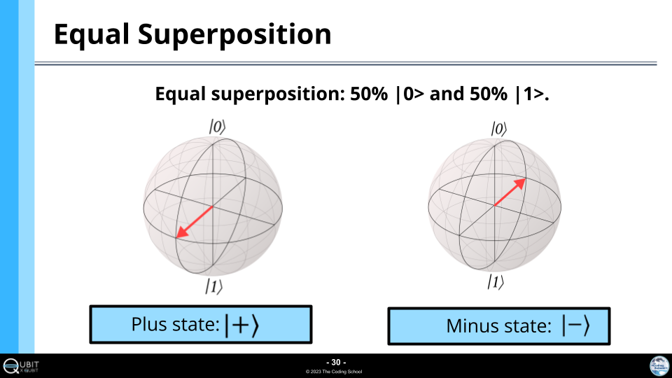

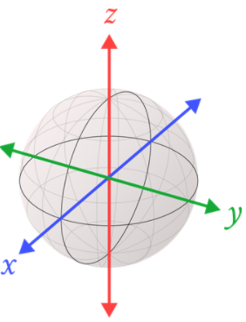

1. **Quantum Gates:** Quantum gates manipulate or change the state of qubits. Gates are how we create superposition, interference, and entanglement! **The operation of gates on qubits can be visualized as rotations on the Bloch sphere.**
   1. To visualize these rotations, we need to associate a coordinate system with the Bloch sphere. Here is the conventional coordinate system:
2. **The X gate:** The operation of the X gate can be summed up as follows:

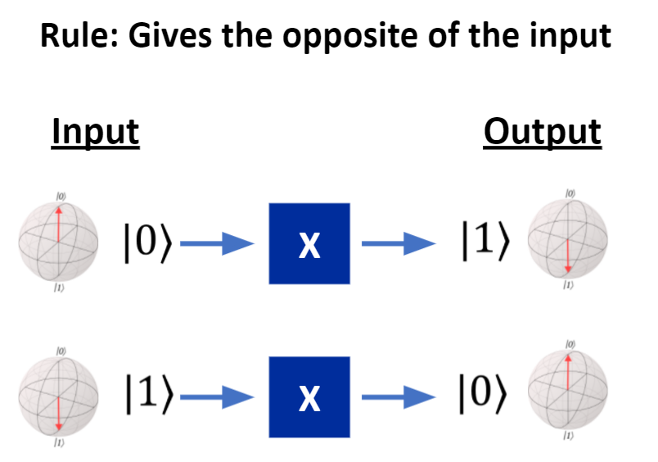

**The X gate can be visualized as a 180 degree rotation about the X axis.**

1. **The H gate:** The H gate creates **superposition**. It is a uniquely quantum gate!

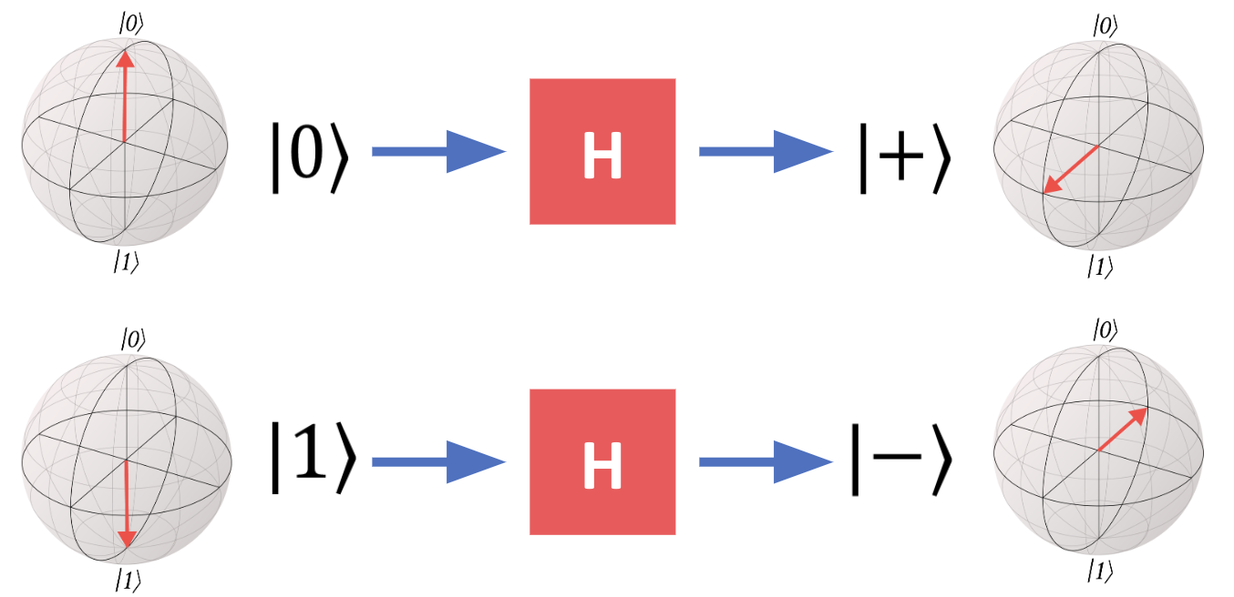

**Remember,** [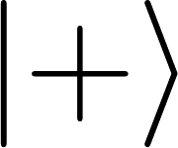](https://www.codecogs.com/eqnedit.php?latex=%7C%20%2B%20%5Crangle%20#0) **and** [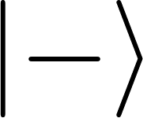](https://www.codecogs.com/eqnedit.php?latex=%7C%20-%20%5Crangle%20#0) **represent two superposition states** **here.**

1. **Quantum Measurement** is the final step in any quantum circuit. This step is critical! Without it, we would just run gates all day long without actually knowing the value of the outcomes.
   1. **Key concept:** Measurement answers the question: Is this qubit in a |0> state or |1> state?
   2. Before measuring, we can only know the probabilities of different outcomes.
   3. When we make a measurement, we get one of these possible outcomes.

We learned two key characteristics of quantum measurement:

1. The **results of measurements** on quantum objects can be **random**, that is, we might not be able to predict the exact outcome of the measurement
2. The **state of the quantum object** being measured can **change** as a result of the measurement.

What actually happens when we measure?

* When we perform measurement, we collapse the quantum state to one state - |0> or |1>.
* We see this collapse reflected in the state’s wave representation. Measurement inherently affects the wave representation of your quantum object.

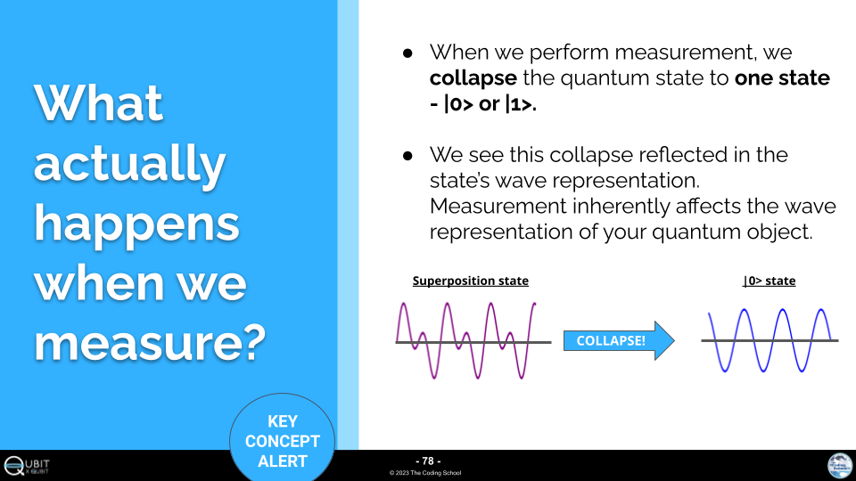

In quantum computation, we represent measurement with this symbol:

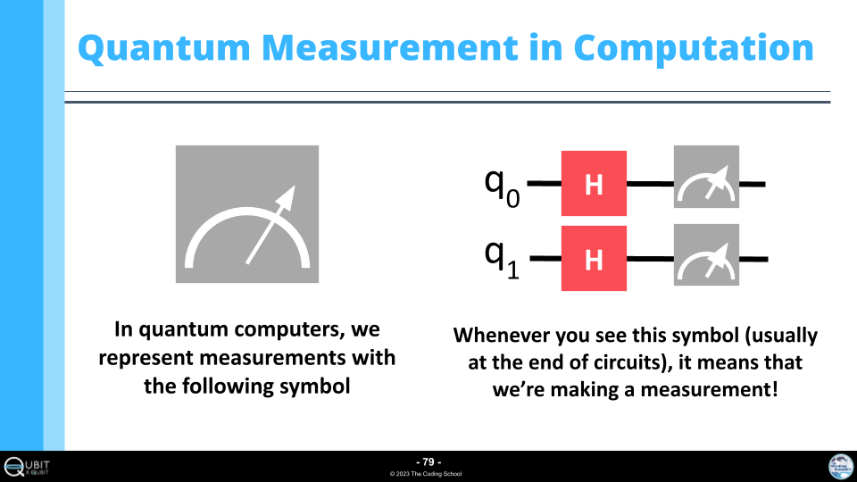

Whenever you see this symbol (usually at the end of circuits), it means that we’re making a measurement!



When making a measurement on a quantum state where we cannot predict the outcome (like a superposition), two things occur:

1. **Random selection:** The measurement gives us either |0> or |1>, completely randomly.
2. **State Change:** The state of the qubit after measurement is either |0> or |1>. It changes because of the measurement. (This is the wavefunction collapse!)

**Lab: Introduction to Q#**

Today, we learned how to code quantum circuits in Q#. Here is some background information on quantum circuits that we learned in lab:

**Quantum circuits** are collections of quantum gates.

1. We draw them as:

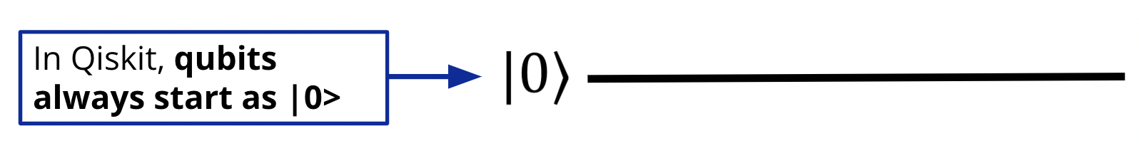

***(In Q#, all qubits start in the |0> state)***

1. We can add as many gates as we want to our circuit:

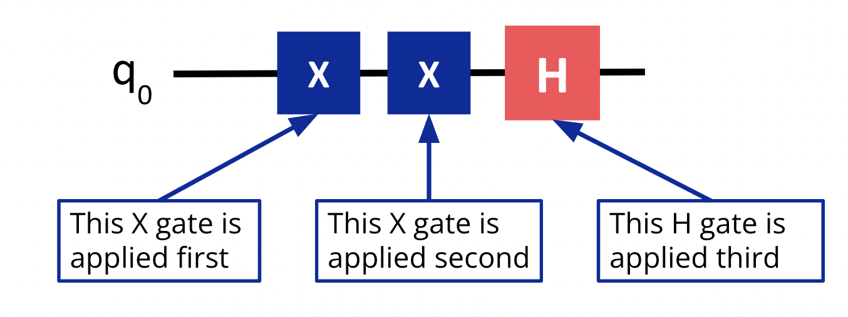

1. We can have multiple qubits in our circuit or even classical bits, which are draw with double lines:

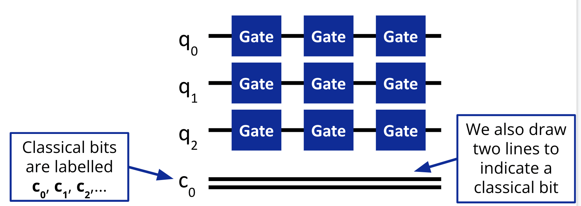

We learned the four key steps of running quantum code in Q#: (Steps 1, 3, and 4 are in Python, while step 2 is in Q#):

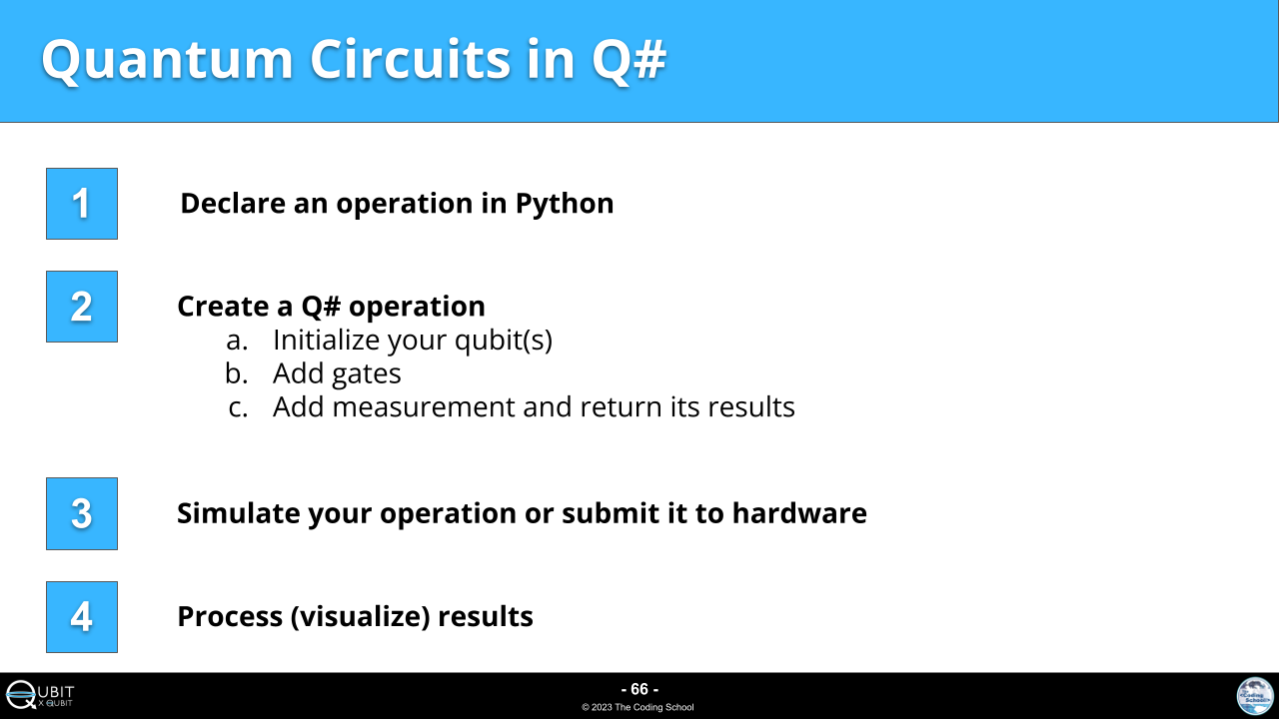

We learned basic data types in Q#, which can be found in the [Q# cheat sheet](https://docs.google.com/document/d/1OwAQL3NGkYDeW7Y1xO9p7eowfL7RHo0DUl8QDovPYvI/edit?usp=sharing).

After running the code, we learned how to visualize and interpret the results:

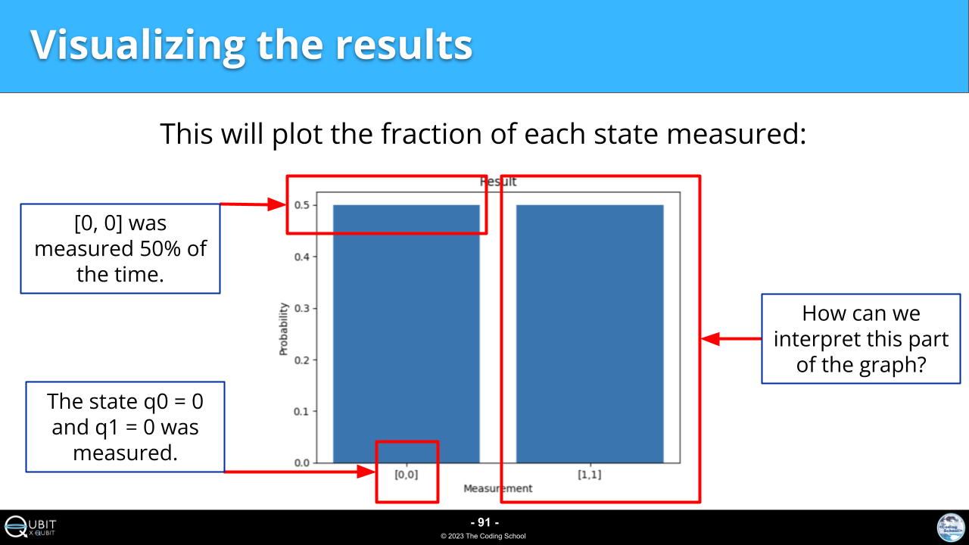

*Answer to the above question: [1,1] was measured 50% of the time. This state is when q0 = 1 and q1 = 1.*

Finally, we learned our first multi-qubit quantum gate, the CX Gate:

